**Project Design Phase-II**

**Data Flow Diagram & User Stories**

|  |  |
| --- | --- |
| Date | 15 October 2022 |
| Team ID | PNT2022TMID47172 |
| Project Name | Digital Naturalist - AI Enabled tool for Biodiversity Researchers |
| Maximum Marks | 4 Marks |

**Data Flow Diagrams:**

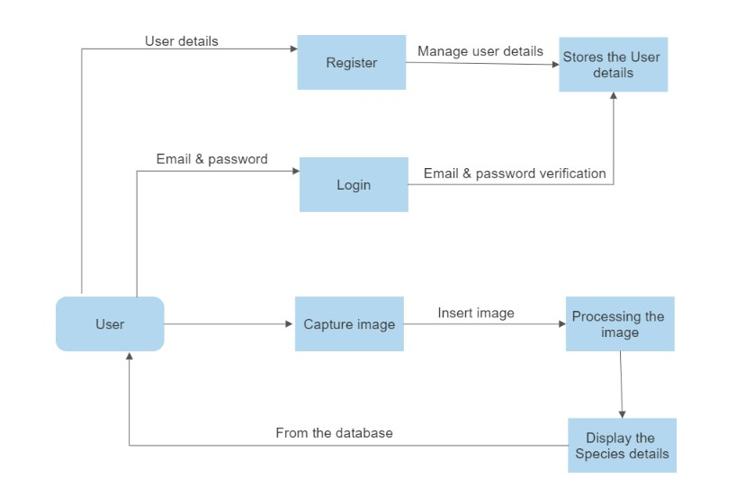

**User Stories**

|  |  |  |  |  |  |  |
| --- | --- | --- | --- | --- | --- | --- |
| **User type** | **Functional**  **Requirement (Epic)** | **User**  **Story**  **Number** | **User Story / Task** | **Acceptance criteria** | **Priority** | **Release** |
| User | Registration | USN-1 | As a user, I can register for the application by entering my email, password, and confirming my password. | I can access my account / dashboard | High | Sprint-1 |
| Confirmation | USN-2 | As a user, I will receive confirmation email once I have registered for the application | I can receive confirmation email & click confirm | High | Sprint-1 |
| Login | USN-3 | As a user, I can log into the application by entering Gmail and password. | I can access the dashboard with Gmail account. | Low | Sprint-2 |
| Capturing | USN-4 | As a user, I can capture the image of the species. | I can store the photo in the devices. | High | Sprint-1 |
| Upload | USN-5 | As a user, I can upload of the image of the species. | The image fed into the web application. | High | Sprint-1 |
| Admin | Processing and Display | USN-6 | As a Admin, I can display the details of the species. | I can view the details of the species. | High | Sprint-2 |